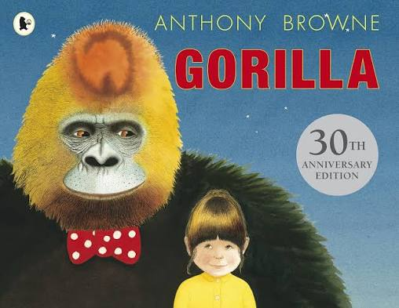
English
We will be studying the book ‘Gorilla’ by Anthony Browne this half term. The children will be using nouns and pronouns to avoid repetition, learning about fronted adverbials and how to correctly punctuate them, and organising paragraphs around a theme. We will have weekly spelling lessons and a spelling test every Friday so please help your child to practice their spellings at home.
Welcome to Year 4! I am so excited to start the next step of your learning journey and I am looking forward to getting stuck in to all of the wonderful things we have planned for this year. New school years can be daunting so, if you have any questions or queries about your child’s learning or well-being, please do not hesitate to catch me before or after school or drop me a message on Dojo.
Kind regards, Mrs Gray



Sunnyfields Primary School
Lavender class newsletter Autumn Term 1 2026

Reading
We will be handing out reading books over the course of the week and children will also receive a new planner once they have been delivered to school. Please continue to listen to your child read 3 times a week and sign their planner so they can receive their ‘Reading at home’ dojo.
Maths
In mathematics this half term, we will be partitioning, rounding, comparing and ordering numbers to 10,000! We will also be recapping written methods for solving addition, subtraction, multiplication and division calculations.
All Year 4 children will be sitting the Multiplication Tables Check (MTC) in June. This is a statutory online assessment in England that tests pupil’s recall of their times tables up to 12 x 12. We will be practising our times tables daily and will have a weekly times table test every Friday.

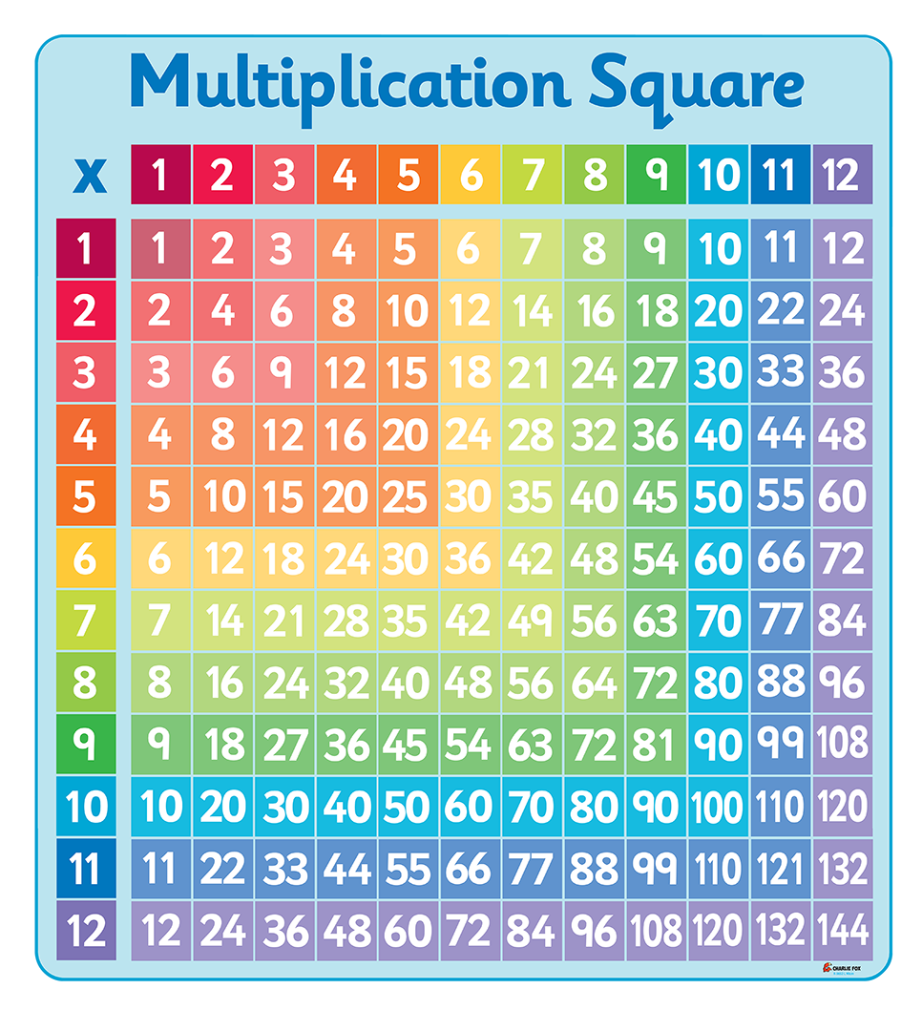

PE
The children will be doing Dance indoors with Miss Mitchell on Wednesday mornings and Basketball outdoors with Mrs Atkinson on Thursday afternoons.
Please ensure your child comes to school wearing their PE kits on these days. A reminder that PE kits should be non-branded items that conform to the school’s colours (red, black, white, grey or navy).
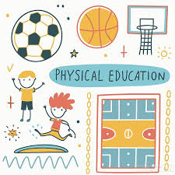
Dates for your diary
Friday 11th September – Online safety day
Friday 18th September – Individual school photos
Thursday 24th September – Parent’s phonics workshop
Friday 2nd October – Macmillan Coffee Morning
Wednesday 7th October – Parent’s evening
Friday 23rd October – Break up for Half term
The wider curriculum
In History, we will be learning about how children’s lives have changed over time by investigating leisure, health and work in the past. The children will compare Tudor and Victorian England and learn how Lord Shaftesbury helped change the lives of children.
In art and design, the children will be drawing. They will be exploring tone, texture and proportion to create realistic and expressive drawings inspired by artists Sarah Graham, Nicola McBride and Beatriz Milhazes.
Our science this half term focusses on electricity and circuits. The children will be exploring electrical components and conductivity through circuit building and real-life applications.
In RE the children will be learning about how the lives of the Gurus inspire Sikhs. They will learning more about Sikhism and what it means to be a Sikh in today’s world.
The children will be learning about online safety in computing this half term. They will learn how to make good choices and what to look out for.
In music, we will be exploring body and tuned percussion to listen and respond and create our own tunes.

